MATH 243 — Probability and Statistics
The Normal Distribution: Areas, Percentiles, Linear Combinations and Approximations
Lesson notes · Exam approach · TF practice with solutions · Quick notes (KKS Sir's portion — Probability & ANOVA)

How to Read These Notes
EXAM FOCUS | Exam importance, where it appears in the TF collection
MEMORIZE | Rules, tables and formulas to memorize
TRAP | Common mistakes and exam traps
EXAM-READY ANSWER | Model wording you can write in the exam
NOTE | Extra explanation / clarification
Grey box, monospace | Code, worked tables, derivations and hand-drawn sketches
Centered grey box | Formula to remember / final numerical result
Purple heading / ✔ green | Practice questions / their solutions

Contents
Exam Map — What the TF Papers Ask — a normal-table question in every paper since 2014-15
Lesson 16 — Normal Distribution, Standardising and the z Table — pdf, properties, areas, finding k, all TF numericals
Lesson 17 — Sums of Normals, Sampling Distribution of x̄, Normal Approximation — D = A − B − C, σ/√n, finite population correction, continuity correction
Quick Notes — Normal Distribution — revision bullets
NOTE Page numbers refer to KKS Sir's Lecture 12.pdf (11 pp.) and Lecture on other distributions...pdf (uniform and normal, pp. 7–10). Table values are read from standardnormaltable.pdf (area to the left of z, z rounded to two decimals). Sums of independent normals and the sampling distribution of x̄ are textbook topics (marked). "TF p." = merged question PDF page; "22 batch p." = 2023-24 paper.

Exam Map — What the TF Papers Ask
Session (paper) | Questions answered by this note [lesson]
2023-24 (MATH 243)  TF p. 22 batch p.2 | Q4(a) Show mode of normal = μ; bulbs N(800, 40²): P(778 < X < 834) (11) [L16]
2022-23 (MATH 243)  TF p. 48 | Q3(c) Lawyer's trip N(24, 3.8²): P(≥ 30 min), % late, slowest 15 %, P(2 of next 3 trips ≥ 30 min) (13) [L16] · Q4(a) Properties of the normal curve; mean, mode and SD of the normal; mean and variance of the standard normal (10) [L16]
2021-22 (MATH 245)  TF p. 45 | Q7(b) Ball bearings 3.0 ± 0.01 cm, N(3.0, 0.005²): how many are scrapped (15) [L16]
2020-21 (MATH 245)  TF p. 38 | Q7(b) Mice lifetimes N(40, 6.3²): P(> 32 months), P(37 to 49 months) (18) [L16]
2018-19 (MATH 245)  TF p. 25 | Q8(a) 1000 tube lights N(120, 20²): how many fail before 90 days; replacement interval so that ≤ 10 % fail (18) [L16]
2016-17 (MATH 245)  TF p. 21 | Q7(b) U-shaped part: A ~ N(10, 0.1²), B, C ~ N(2, 0.05²); gap D = A − B − C: mean, sd, P(D < 5.9) (10) [L17] · Q7(c) 1500 bearings, mean 22.40 g, sd 0.048 g; 300 samples of 36: mean and sd of x̄ (with/without replacement); counts in ranges (15) [L17]
2015-16 (MATH 241)  TF p. 16 | Q8(b) Normal marks: 10 % under 65, 25 % above 75 — what % lie between 60 and 74 (12) [L16]
2014-15 (MATH 241)  TF p. 11 | Q8(c) 2000 units/day, weight N(130, 10²): how many weigh less than 142 kg (11) [L16]

EXAM FOCUS 10 questions, 133 marks. Every paper from 2014-15 on has a normal-table numerical (11–18 marks): a count out of N, a percentage between two values, or a reverse lookup ("replacement interval so that ≤ 10 % fail", "slowest 15 %"). The 2022-23 and 2023-24 papers add theory: properties of the normal curve and why mean = mode = μ. Practise the four-line routine of Lesson 16 until a question takes five minutes.

Lesson 16 — Normal Distribution, Standardising and the z Table
Lec 12 pp. 1–8 · other distributions pp. 7–10

1. Definition (Lec 12 p. 1)
f(x) = [1/(σ√(2π))] e^{−(x − μ)²/(2σ²)}, −∞ < x < ∞
X ~ N(μ, σ²): E(X) = μ, V(X) = σ²
Normal probability law: P(μ − σ < X < μ + σ) = 68.27 %, P(μ − 2σ < X < μ + 2σ) = 95.45 %, P(μ − 3σ < X < μ + 3σ) = 99.73 %. The normal distribution is also called the Gaussian distribution.

2. Properties of the Normal Curve ★ (textbook; asked 2022-23 Q4(a))
1. Bell-shaped and symmetric about x = μ; mean = median = mode = μ.
2. The curve is highest at x = μ, where f(μ) = 1/(σ√(2π)).
3. Points of inflection at x = μ ± σ (concave down between them, up outside).
4. It approaches the x-axis asymptotically on both sides; total area under the curve is 1.
5. Determined completely by μ (location) and σ (spread); larger σ → lower, flatter curve.
6. A linear function a + bX of a normal variable is normal; so is a sum of independent normals.
7. Mean deviation ≈ (4/5)σ, quartile deviation ≈ (2/3)σ; β₁ = 0 (symmetric), β₂ = 3 (mesokurtic).

3. Mean, Mode and SD of the Normal ★ (textbook; 2022-23 Q4(a), 2023-24 Q4(a))
Mode: maximise f(x). ln f = const − (x − μ)²/(2σ²)
d/dx ln f = −(x − μ)/σ² = 0 ⟹ x = μ; d²/dx² ln f = −1/σ² < 0 ⟹ maximum. Mode = μ.

Mean: put z = (x − μ)/σ, dx = σ dz:
E(X) = ∫ (μ + σz) φ(z) dz = μ ∫ φ(z) dz + σ ∫ z φ(z) dz = μ · 1 + σ · 0 = μ
(∫ z φ(z) dz = 0 because z φ(z) is an odd function)

Variance: E[(X − μ)²] = σ² ∫ z² φ(z) dz. By parts with u = z, dv = z e^(−z²/2) dz:
∫ z² e^(−z²/2) dz = [−z e^(−z²/2)] + ∫ e^(−z²/2) dz = 0 + √(2π)
⟹ ∫ z² φ(z) dz = 1 ⟹ V(X) = σ², SD = σ

4. Standard Normal Variable (Lec 12 pp. 1–2)
Z = (X − μ)/σ ~ N(0, 1), φ(z) = (1/√(2π)) e^{−z²/2}
Φ(z) = P(Z ≤ z) = area to the left of z
E(Z) = (1/σ)[E(X) − μ] = 0 and V(Z) = (1/σ²)V(X) = 1: the standard normal has mean 0 and variance 1, so any normal probability is read from one table.
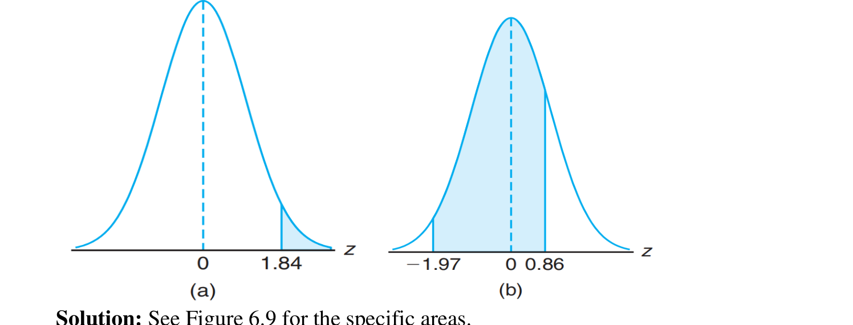
Figure 16.1 — Areas to the right of z = 1.84 and between z = −1.97 and 0.86 (Lec 12 p. 4)

5. Worked Examples (Lec 12 pp. 2–6)
Right of z = 1.84: 1 − 0.9671 = 0.0329. Between −1.97 and 0.86: 0.8051 − 0.0244 = 0.7807
GPA N(2.1, 0.6²), 80 students: P(2.5 < X < 3.5) = P(0.67 < Z < 2.33) = 0.9901 − 0.7486 = 0.2415 → ≈ 19 students
N(50, 10²): P(45 < X < 62) = P(−0.5 < Z < 1.2) = 0.8849 − 0.3085 = 0.5764
Ball bearings 3.0 ± 0.01, σ = 0.005: z = ±2, scrapped = 2(0.0228) = 0.0456 → 4.56 %
N(25, 9): 30 % to the left: z = −0.525 → K = 25 − 0.525(3) = 23.425; 15 % to the right: z = 1.035 → K = 28.105

NOTE The slide reads Φ(0.67) as 0.7480 (that is Φ(0.668)); the table gives 0.7486, so the probability is 0.2415 and the expected number 19.3 ≈ 19 (the slide's 0.2421 × 80 = 19.4 also rounds to 19, not 20).

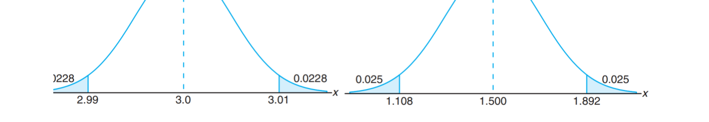
Figure 16.2 — Scrapped ball bearings: two tails of 0.0228 beyond z = ±2 (Lec 12 p. 6)

6. Uniform Distribution (other distributions pp. 7–8)
f(x) = 1/(B − A), A ≤ x ≤ B; μ = (A + B)/2, σ² = (B − A)²/12
Conference room, X ~ U[0, 4]: f(x) = 1/4; P(X ≥ 3) = ∫₃⁴ (1/4) dx = 1/4.

Exam Approach
1. Write X ~ N(μ, σ²) with σ (not σ²) ready.
2. Standardise every limit: z = (x − μ)/σ, rounded to 2 decimals.
3. Area: left Φ(z); right 1 − Φ(z); between Φ(z₂) − Φ(z₁). Draw a small sketch with the shaded area.
4. Count = N × probability (round to a whole number). Reverse question: find z with the given area, then x = μ + zσ. Two unknowns: two such equations, solve for μ and σ.

Practice — Lesson 16
(a) Actual — 2018-19 Q8(a) (TF p. 25). (b) Actual — 2014-15 Q8(c) (TF p. 11). (c) Actual — 2020-21 Q7(b) (TF p. 38). (d) Actual — 2022-23 Q3(c) (TF p. 48). (e) Actual — 2015-16 Q8(b) (TF p. 16). (f) Actual — 2021-22 Q7(b) (TF p. 45). (g) Actual — 2023-24 Q4(a) (22 batch p. 2). (h) Actual — 2022-23 Q4(a) (TF p. 48).
(a) A factory installed 1000 tube lights with mean life 120 days, normally distributed with SD 20 days. (i) How many expire in less than 90 days? (ii) If all are replaced together, what interval should be allowed between replacements if not more than 10 % should expire before replacement? (18)
(b) A workshop produces 2000 units per day with mean weight 130 kg and SD 10 kg (normal). How many units weigh less than 142 kg? (11)
(c) Mice live on average 40 months with SD 6.3 months (normal). Find P(lives more than 32 months) and P(between 37 and 49 months). (18)
(d) A one-way trip takes on average 24 minutes, SD 3.8 minutes (normal). P(trip takes at least half an hour)? (i) Office opens at 9:00, he leaves at 8:45: what percentage of the time is he late? (ii) Time above which the slowest 15 % of trips lie. (iii) P(2 of the next 3 trips take at least half an hour). (13)
(e) Marks are normal; 10 % of students score under 65 and 25 % exceed 75. What percentage score between 60 and 74? (12)
(f) Ball bearings must be 3.0 ± 0.01 cm; diameters are N(3.0, 0.005²). On average how many are scrapped? (15)
(g) Show that the mode of the normal distribution equals its mean. Bulb life is N(800, 40²): find P(778 < X < 834). (11)
(h) Write some properties of the normal curve. Find the mean, mode and SD of a normal random variable and comment on the mean and variance of the standard normal variable. (10)

✔ Solution
(a) X ~ N(120, 20²).
(i) z = (90 − 120)/20 = −1.5; P(X < 90) = Φ(−1.5) = 0.0668
expected number = 1000 × 0.0668 = 66.8 ≈ 67 tube lights
(ii) want P(X < t) = 0.10 → z = −1.28 (table: Φ(−1.28) = 0.1003)
t = 120 − 1.28 × 20 = 94.4 days → replace every 94 days (about 3 months)

(b)
z = (142 − 130)/10 = 1.2; P(X < 142) = Φ(1.2) = 0.8849
number = 2000 × 0.8849 = 1769.8 ≈ 1770 units

(c) X ~ N(40, 6.3²).
z = (32 − 40)/6.3 = −1.27; P(X > 32) = 1 − Φ(−1.27) = 1 − 0.1020 = 0.898
z₁ = (37 − 40)/6.3 = −0.48, z₂ = (49 − 40)/6.3 = 1.43
P(37 < X < 49) = Φ(1.43) − Φ(−0.48) = 0.9236 − 0.3156 = 0.608

(d) X ~ N(24, 3.8²).
P(X ≥ 30): z = 6/3.8 = 1.58 → 1 − 0.9429 = 0.0571
(i) late if the trip takes more than 15 min: z = (15 − 24)/3.8 = −2.37 → P = 1 − 0.0089 = 0.9911 → 99.11 % of the time
(ii) slowest 15 %: P(X > t) = 0.15 → Φ(z) = 0.85 → z = 1.04; t = 24 + 1.04 × 3.8 = 27.95 min
(iii) Y = number of the 3 trips ≥ 30 min ~ Bin(3, 0.0571): P(Y = 2) = 3(0.0571)²(0.9429) = 0.0092

(e) Two unknowns: use both percentages.
P(X < 65) = 0.10 → (65 − μ)/σ = −1.28; P(X > 75) = 0.25 → (75 − μ)/σ = 0.67
Subtract: 10/σ = 1.95 → σ = 5.1282; μ = 65 + 1.28σ = 71.5641
z(60) = (60 − 71.56)/5.128 = −2.26; z(74) = (74 − 71.56)/5.128 = 0.47
P(60 < X < 74) = Φ(0.48) − Φ(−2.26) = 0.6844 − 0.0119 = 0.6725 ≈ 67 %

(f) z = (2.99 − 3.0)/0.005 = −2 and (3.01 − 3.0)/0.005 = 2; P(scrapped) = 2Φ(−2) = 2(0.0228) = 0.0456 → 4.56 % of the bearings (about 46 in every 1000).
(g) Mode = μ: the derivative proof of §3. Then X ~ N(800, 40²):
z₁ = (778 − 800)/40 = −0.55, z₂ = (834 − 800)/40 = 0.85
P(778 < X < 834) = Φ(0.85) − Φ(−0.55) = 0.8023 − 0.2912 = 0.5111

(h) Properties: §2 list (give at least five). Mean, mode, SD: §3 derivations. Comment: Z = (X − μ)/σ has mean 0 and variance 1 (§4), so every normal variable reduces to N(0, 1), which is why one table serves all normal distributions.

Lesson 17 — Sums of Normals, Sampling Distribution of x̄, Normal Approximation
Lec 12 pp. 6–11 · linear combinations and x̄: textbook

1. Linear Combinations of Independent Normals (textbook)
X_{i} ~ N(μ_{i}, σ_{i}²) independent ⟹ Y = Σ a_{i}X_{i} ~ N(Σ a_{i}μ_{i}, Σ a_{i}²σ_{i}²)
TRAP Variances add even when the variables are subtracted: V(A − B) = V(A) + V(B). Never subtract SDs.

2. Sampling Distribution of the Mean (textbook; Lec 12 p. 8 exercise 7)
E(x̄) = μ, σ_{x̄} = σ/√n (with replacement / infinite population)
Without replacement from N: σ_{x̄} = (σ/√n) √((N − n)/(N − 1))
If the population is normal, x̄ is exactly normal; otherwise it is approximately normal for large n (central limit theorem). For two independent samples, x̄₂ − x̄₁ ~ N(μ₂ − μ₁, σ₁²/n₁ + σ₂²/n₂).
Lec 12 exercise 7 (old N(5000, 40²), n = 16; improved N(5050, 30²), n = 25): x̄₂ − x̄₁ has mean 50, SD √(900/25 + 1600/16) = √136 = 11.6619; P(difference ≥ 25) = P(Z ≥ −25/11.66) = P(Z ≥ −2.14) = 0.9838.

3. Normal Approximation to the Binomial (Lec 12 pp. 6–11)
X ~ Bin(n, p) ≈ N(np, np(1 − p)) when np ≥ 5 and n(1 − p) ≥ 5
Continuity correction: P(a ≤ X ≤ b) ≈ P(a − 0.5 < Y < b + 0.5)
Bin(10, 0.5): exact P(2 ≤ X ≤ 4) = 0.3662
normal μ = 5, σ = √2.5 = 1.581: P(1.5 < Y < 4.5) = P(−2.21 < Z < −0.32) = 0.3745 − 0.0136 = 0.3609
Pipework failures, n = 20, p = 0.3 (μ = 6, σ = 2.049):
P(X ≥ 10) ≈ P(Y ≥ 9.5) = P(Z ≥ 1.71) = 0.0436; P(X ≤ 4) ≈ P(Y ≤ 4.5) = P(Z ≤ −0.73) = 0.2327
Exactly 5 observed: z = (5 − 6)/2.049 = −0.49, |z| < 1.96 → no evidence against the 30 % rate

NOTE The slide's last line writes P(Z ≤ −0.21) for the left limit; it is z = −2.21 (area 0.0136), as used. With np = 5 exactly the approximation is borderline, which is why 0.36 differs from 0.3662.

Exam Approach
1. Write the combination (D = A − B − C, x̄, x̄₂ − x̄₁) and its mean and variance first.
2. Standardise with that SD (σ/√n for a mean, with the finite-population factor if sampling without replacement).
3. For counts out of many samples, multiply the probability by the number of samples.
4. Binomial → normal: check np, nq ≥ 5, apply the ±0.5 correction, then standardise.

Practice — Lesson 17
(a) Actual — 2016-17 Q7(b) (TF p. 21). (b) Actual — 2016-17 Q7(c) (TF p. 21).
(a) A U-shaped component is formed from parts A, B and C (Figure 17.1). The length of A is N(10, 0.1²) mm; the thicknesses of B and C are N(2, 0.05²) mm; all independent. (i) Find the mean and SD of the gap D. (ii) What is the probability that D is less than 5.9 mm? (10)
(b) The masses of 1500 ball bearings are normal with mean 22.40 g and SD 0.048 g. If 300 random samples of size 36 are drawn, find the expected mean and SD of the sampling distribution of means for sampling with and without replacement. How many samples would have means (i) between 22.39 and 22.41 g, (ii) greater than 22.42 g, (iii) less than 22.38 g or more than 22.41 g? (15)
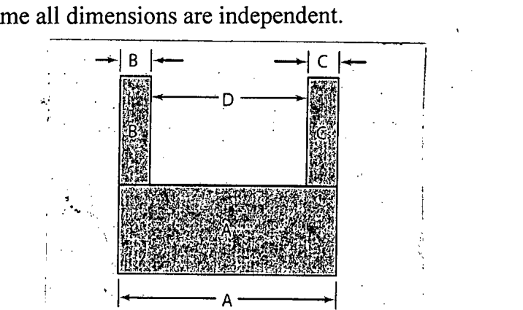
Figure 17.1 — The U-shaped component: D = A − B − C (2016-17 Q7(b), TF p. 21)

✔ Solution
(a) D = A − B − C, a linear combination of independent normals.
(i) E(D) = 10 − 2 − 2 = 6 mm
V(D) = 0.1² + 0.05² + 0.05² = 0.01 + 0.0025 + 0.0025 = 0.015; SD = √0.015 = 0.1225 mm
(ii) z = (5.9 − 6)/0.1225 = −0.82; P(D < 5.9) = Φ(−0.82) = 0.2061

(b) μ_{x̄} = μ = 22.40 g in both cases.
With replacement: σ_x̄ = 0.048/√36 = 0.008 g
Without replacement: σ_x̄ = 0.008 × √((1500 − 36)/(1500 − 1)) = 0.008 × 0.9883 = 0.00791 g

Sampling | σ_{x̄} | z for ±0.01 | (i) prob → of 300 | (ii) prob → of 300 | (iii) prob → of 300
with replacement | 0.008 | 1.25 | 0.7888 → 236.6 | 0.0062 → 1.9 | 0.1118 → 33.5
without replacement | 0.00791 | 1.26 | 0.7924 → 237.7 | 0.0057 → 1.7 | 0.1095 → 32.9

Working (with replacement): (i) z = ±0.01/0.008 = ±1.25, P = Φ(1.25) − Φ(−1.25) = 0.8944 − 0.1056 = 0.7888 → about 237 samples; (ii) z = 0.02/0.008 = 2.5, P = 1 − 0.9938 = 0.0062 → about 2 samples; (iii) P(x̄ < 22.38) + P(x̄ > 22.41) = 0.0062 + 0.1056 = 0.1118 → about 34 samples. Without replacement the counts are 238, 2 and 33.

Quick Notes — Normal Distribution
Revision points for Lessons 16–17.

L16 · Normal and z
- f = e^{−(x−μ)²/2σ²}/(σ√2π); mean = median = mode = μ; inflection μ ± σ; 68.27/95.45/99.73 %.
- Z = (X − μ)/σ ~ N(0, 1); Φ(z) = area left; right = 1 − Φ; between = difference.
- Mode: d/dx ln f = 0 → x = μ. Mean via z, odd integrand; variance by parts → σ².
- Tube lights 67 and 94.4 days; units 1770; mice 0.8980, 0.6080; trip 0.0571, 99.1 %, 27.95 min, 0.0092;
- marks μ = 71.56, σ = 5.13 → 67 %; bearings 4.56 %; bulbs 0.5111.

L17 · Combinations and Approximations
- Σa_{i}X_{i} ~ N(Σa_{i}μ_{i}, Σa_{i}²σ_{i}²): variances always add.
- σ_{x̄} = σ/√n; × √((N − n)/(N − 1)) without replacement.
- U-shape: D ~ N(6, 0.1225²), P(D < 5.9) = 0.2061. Bearings: 237, 2, 34.
- Binomial ≈ normal if np, nq ≥ 5; use ±0.5 continuity correction.

Key Diagrams to Reproduce
Two-tail scrap area (Lec 12 p. 6) — same as Fig. 16.2

